**Maven Marketing Analysis**

My name is **Akinfe Taiwo Oluwabamise**. I am a data analyst tasked with performing a detailed analysis of the data of Maven Marketing. I have critically analysed the data set and I have the confident that these actionable insights will help the company achieve its goal of strategic decision making.

**Introduction**

This company is a Store that sells variety of products like wines, fruits, meat products, fish, sweet and gold products. There Products were sold in different countries like Spain, Canada, USA, Australia, Germany, India, Mexico and Saudi Arabia respectively.

They made used of different channels like Catalogue, store and Web to reach their various customers across the region.

**Data**

The data was located in the company’s database and stored as a .xlsx file. The data is primary data collected by the company itself. This makes it highly reliable.

**Data Processing**

Microsoft Excel was used for data preparation, exploration and visualization. I chose this tool because of its versatility and data organization functions which makes insight generation easier.

I cleaned the data and prepared it for analysis.

Analysis was done using different excel functions and the pivot table.

**Results**

**Total Customers: 2240**

**Educational Background of Customers**

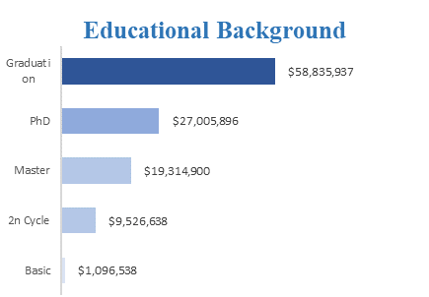

The Educational background of the customers really determined the revenue of the company which shows that those that falls into graduate category purchase more from the store than the basic.

**Product Performance**

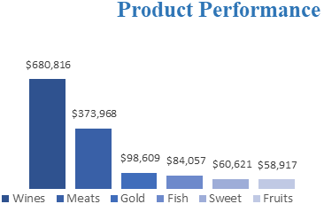

Wine generated the most revenue for Maven store unlike fruits products which has the lowest sales.

**Channel performance**

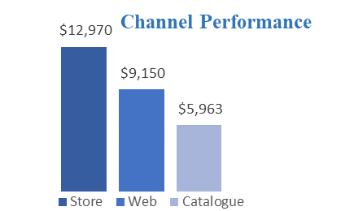

Maven Store make use of three channels which are Store, web and catalogue to sell their products to their customers, people visits physical Store than using other channel which makes it to generate more revenue for the company.

**Country Analysis**

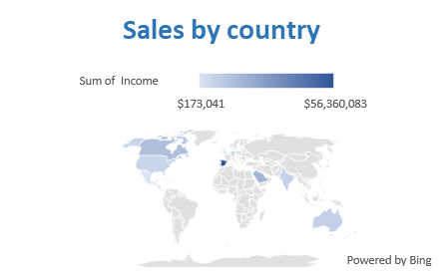

|  |  |  |
| --- | --- | --- |
| **Countries** | **Sum of Income** | |
| Spain | $ 56,360,083 |  |
| Saudi Arabia | $ 18,477,985 |  |
| Canada | $ 14,111,464 |  |
| Australia | $ 7,615,230 |  |
| India | $ 7,205,413 |  |
| Germany | $ 6,142,327 |  |
| USA | $ 5,694,366 |  |
| Mexico | $ 173,041 |  |

Spain made most of the sales with total income of $56,360,083 while Mexico generated the least sales with income of $173,041

**Campaign Performance**

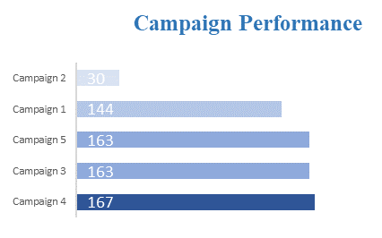

Campaign is the number of times advertisement were being made and the numbers of customers that accepted and patronized Maven each time the campaign was made. Campaign 4 generated the most sales for Maven Store.

**Recency of Purchase**

The differences in the number of times since customers last purchase products from Maven

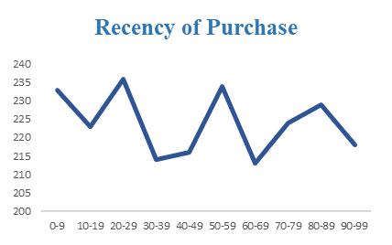

**Marital status of customers**

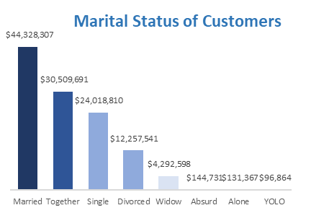

From the chart above, it shows that the Married patronised Maven store than other segment of their customers.

**Recommendations**

1. Maven Store should stock more wines in order to increase more sales of the company.

2. The store should channel more energy of campaign to the country with the lowest sales.

3. The store should work more the Catalogue purchase by increasing the number of campaign through that channel, thereby increasing their sales.

4. Customers with the highest purchase on all channel should be rewarded with quarterly or end of the year gift.

**Questions.**

What factors are significantly related to the number of web purchases?

Which marketing campaign was the most successful?

What does the average customer look like?

Which products are performing best?

Which channels are underperforming?

Provide recommendations.